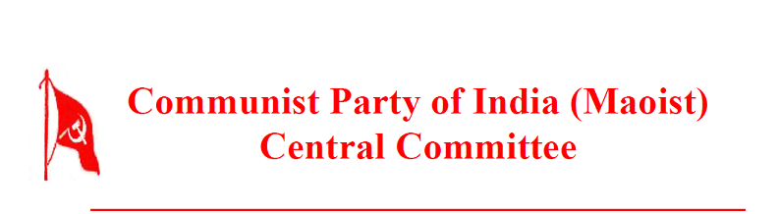

International Department

January 2, 2015

To
Central Committee,
Communist (Maoist) Party of Afghanistan.

Dear Comrades,

We humbly pay homage to the martyrs of the Afghanistan revolutionary movement, in particular to your Central Committee member comrade Aziz. The sacrifices made by these heroic proletarian fighters will forever remain a source of inspiration to the people.
The successful completion of the Second Congress of your party is a joyful and inspiring event. On behalf of our Central Committee, the People’s Liberation Guerrilla Army, the Revolutionary People’s Committees and the revolutionary masses we greet you with a resounding Lal Salam on your grand achievement.
The Maoist movement of Afghanistan has a long history. You represent that revolutionary tradition and continue to take it forward. Afghanistan is situated at a key point, connecting Central and South Asia. Politically, it is of immense importance as a warfront against imperialism, particularly US imperialism. This is even more so because the red banners of the international proletariat contest for the vanguard role in this war with religious ideologies that pull the people backward. The success of your party in tackling and resolving this complex situation and victoriously advancing the new democratic revolution will play a very important role in unleashing the revolutionary potential of these regions. We look forward to learning from the lessons summed up in your Congress and wish you all success in advancing along the line it has laid down.
In conclusion, we cherish the internationalist views expressed in your statement hailing the recent advance in the unity of Maoists in our country and enthusiastically reciprocate its warm sentiments.

with revolutionary greetings,
Arun
International Department,
Central Committee,
Communist Party of India (Maoist)

